Moodle Learner User Guide


Crusader House
Centurion Way
Crusader Business Park
Warminster
Wiltshire
BA12 8BT
Tel: 01985 843100
Email: info@aid-training.co.uk
www.aid-training.co.uk

© AID Training & Operations Ltd 2020

Contents

- Finding your course …………………………………… 3
  - Course information……………………………3
- Opening Documents………………………………………4
- Assignments……………………………………………………4
  - Submitting assignments……………………4
  - Results…………………………………………………5
- Logging out and logging back in……………………6

1. Finding Your Course

Congratulations, you have now logged into your Moodle account and successfully changed your password.
Please ensure that you keep your username and password safe as we at Aid Training do not get to see them. In meeting data protection this remains confidential to protect your details. If you lose these details, and are unable to access the Moodle Platform, then for you to gain access we will need to delete you off the system and re-enrol you. This will mean that everything that has been uploaded to date will be lost and will require uploading once again.

Should you forget your username or password, at the log in page please click on forgotten your username or password? If you can enter your user name or email address then a new electronic password will be generated. If you have forgotten both please contact us at Aid Training on 01985 843100.

Within the home page, (the first page after you log in), if you look down the left-hand side of the page you will see a column of blue boxes. The 2nd box down in this column that is titled My Courses. Within the My Courses box you will find links to any courses that you have been enrolled upon. In order to reach these courses just left click once on the course you wish to view.

1.1. Course Information

Once you have located your course programme, please click on it so that it will take you to the resource page for your course that has been fully explained within the induction PowerPoint presentation that you will have already worked through.
Please ignore the purple boxes on the left-hand side, as these are administration aspects for your assessor to maintain. The right-hand side purple boxes gives information to your assessor regarding your login times and details, so that we can track your learning journey and support your target end dates. This will be seen within the heading such as recent activity.
This page is for you to utilise in terms of all the resources, and the download and upload functions. Once again, these functions have been fully explained within the induction PowerPoint presentation that you will have worked through.

2. Opening Documents

In order to open any documents that you wish to access you need to left click once on the name of the document. Once this is done you will be presented with some options including open, save and save as. Click open if you just wish to view the document, click save as if you wish to save the document to your own computer (you will have to choose a location under which to save it). It is recommended that you save documents you wish to view regularly so that you have access to them if the internet is unavailable.

3. Assignments

In order to complete the course you are enrolled upon, you will be required to complete a number of tasks/assignments; these tasks/ assignments can be accessed from the specific course page that they are for. Left click once on the assignment name in order to bring up the task/assignment page. Once this has opened you will be able to see the task/assignment that is required for you to complete. These tasks/ assignments are to be completed on your computer using word processing software (unless stated otherwise), and uploaded onto the Moodle page for grading by the course teachers/assessors. (See submitting tasks/assignments for help to do this).
The assignment information is also available for you to download and save to your computer in the Learning Resources section of your course page.

3.1. Submitting Tasks/Assignments

In order to submit a task/assignment, you must first go onto the course page and click on the assignment you wish to upload. This will take you to the appropriate task/assignment page and then at the bottom of that page under the submission status section there is a button that says add submission, left click on this box once.

The submission page for the task/assignment will open, on this page you will have to drag and drop the file that contains your assignment into the box labelled file submissions. (Please note that drag and drop is only supported in all recent versions of Chrome, Firefox and Safari, as well as
Internet Explorer v10 and above). If you do not have drag and drop available to you then left click once on the add file button.
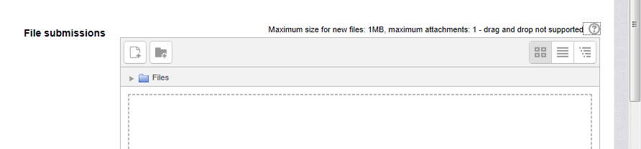

A new window will appear, left click once on the upload a file text and this will bring up an option for you to left click on the browse button and find your file. Then left click once on upload this file.

Once you have done this the file will load into that box. Once it has completed loading click save changes at the bottom of the page.
You will be given a chance to edit your submission on the next page, if you are happy with your submission you must, must, must, must then click submit assignment and then click continue on the next screen. Once this is all done your assignment will have been submitted for marking. Your teacher/assessor will be notified automatically by email that they have a new submission for marking. Failure to complete this full process will not generate an email to Aid Training to say that you have uploaded work ready for assessment. Here, your work will just sit within your page as no-one knows that you have submitted any work. This is your responsibility to ensure that the upload is completed in full.

3.2 Results

Once your task/assignment has been graded by a teacher/assessor you will be notified by an email sent to your email address associated with the Moodle account.

This email will contain a link to the task/assignment page which will now include your grade and any feedback you have been given. You will be given a grade of pass, or referred, along with feedback notes from the teacher/assessor that graded the task/assignment. If you have been awarded referred, please do not worry about this as you will be given the opportunity to resubmit an improved assignment. It is about learning and developing, where your assessor will support you along the way.

Your Moodle page is designed so that one task/assignment can be permitted per task. After this, we would like to ask you to email in your continued task/assignment until that task/assignment has been signed off as final (subject to IQA activity). Your assessor will upload your assessed work for you to view.

4. Logging out and Logging back in

In order to log out from the AID Training Moodle page you will find a log out button on the right-hand side of the black bar at the top of the page, next to your name. Left click this log out button once in order to log out and be taken back to the home page.

In order to log back into the AID Training Moodle platform, left click the log in button located where the log out button was (right hand side of the black bar at the top of the page). This will take you to the log in page where you must enter your username and password and then click log in to log yourself back in.

